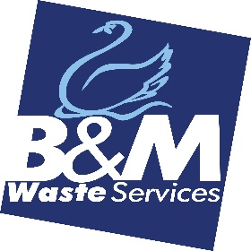

DIGITAL MARKETING EXECUTIVE

Full time, permanent position, working 8.30am – 5pm, Mon to Fri
Applications close 31/08/2022

B&M Waste Services has an exciting opportunity for a skilled creative and results-driven Digital Marketing Executive to join our inhouse Marketing team. The successful candidate will help to devise and deliver the annual marketing plan, with a focus on retaining existing and attracting new business and raising brand awareness via digital channels.
Key Areas of Responsibility:

Main Duties and Responsibilities:
- Responsibility for the design, development and implementation of our digital marketing strategy.
- Work closely with our inhouse team and external digital marketing agency to deliver improvements/enhancements to our website, increase traffic, and in turn, revenue.
- Undertake activities including SEO/SEM, PPC, paid social and display advertising with support from our external digital marketing agency.
- Carry out continual improvement through managing and optimising campaigns to constantly drive ROI.
- In-depth reporting on the performance of our digital marketing strategy.

Skills and Competencies:
- 2 plus years’ experience in a similar role.
- Proven track record of managing websites and digital campaigns and can evidence how these have contributed to revenue growth and customer retention/acquisition.
- Excellent written/verbal communication and interpersonal skills.
- Creative flair, with the ability to create online campaigns that consistently engage, inform, motivate and convert.
- Self-motivated and enthusiastic to learn, with a passion for all things digital.

Location
Although the role will be mainly based at Bromborough HQ, Wirral, travel between depots/offices may be required, therefore a driving licence and own transport is a must.

Recruitment Process
Selected candidates will initially meet with our recruitment manager and marketing team and shortlisted candidates will be invited to a video call and / or a face-to-face interview at our Bromborough Headquarters.

Benefits:
Company pension
Onsite parking
Annual Leave: 23 days plus bank holidays

About Us
B&M Waste Services is an award winning, Carbon Neutral Plus waste management solutions company providing tailored waste collection, recycling and disposal services to businesses across the UK. We are dedicated to supporting our customers, helping them to save money, space and the environment while they achieve their own sustainability and operational targets.

