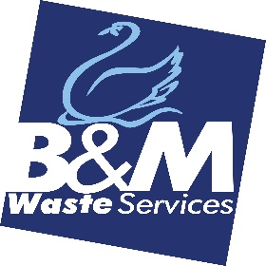
Marketing Administrator
Working 8.30am – 5pm, Mon to Fri
B&M Waste Services has an exciting opportunity for a Marketing Administrator to join the Marketing team.
The successful candidate will support the company’s Marketing Department in delivering general administrative support to the team.
Key areas of responsibility:
Work closely with the Marketing team to provide general administrative support for the following:
- Events - organisation and support
- CRM – export data for analysis
- Manage marketing software subscriptions
- POs, invoices and paperwork for the department
- Minute taking
- Ordering merchandise and/or other marketing items
- Assist in any other tasks relevant to marketing.

The ideal candidate must display the following skills:
- At least 1 year experience working in a similar marketing or administrative role, and be proficient in MS 365 - Word, Excel, PowerPoint, Outlook and MS Teams
- Experience using Canva, Social Sprout (Hootsuite or Content Cal)
- Be highly organised, methodical, flexible and enthusiastic in their approach to work
- Be able to work without close supervision and quickly learn new skills
- Be able to demonstrate management of numerous tasks simultaneously
- Have excellent verbal and written communication skills and pay attention to detail
- Have a positive, can-do approach to their duties.
Desirable Skills (but not necessary)
Experience using Sage CRM, Power BI, Word Press, MailChimp, Survey Monkey
Knowledge of PS, Adobe
Location
Although the role will be mainly based at Bromborough HQ, Wirral, travel between depots/offices may be required, therefore a driving licence and own transport is a must.
Recruitment Process
Selected candidates will be offered an ‘in person’ interview at Bromborough HQ
Job Type: Full-time, permanent working Mon to Fri 8.30am – 5pm
Annual Leave: 23 days plus bank holidays
Benefits:
Company pension
Onsite parking
Application deadline: 19/08/2022
About Us
B&M Waste Services is an award winning, carbon neutral plus waste management solutions company providing tailored waste collection, recycling and disposal services to businesses across the UK. With a team of over 250 employees based across 5 regional depots, we are dedicated to supporting our customers, helping them to save money, space and the environment while they achieve their own sustainability and operational targets.

