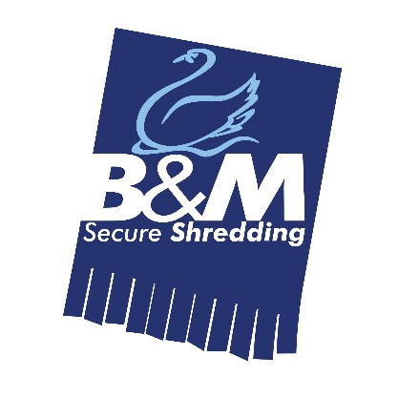
JOB DESCRIPTION
JOB TITLE: Administrator
DEPARTMENT: Additional Services
LOCATION: Bromborough, Wirral
HOURS: Mon to Fri, 8.30am – 5pm
REPORTING TO: General Manager
ROLE: To process customer orders and enquiries for secure shredding, commodities and clearances. Prepare quotations, liaise with suppliers and make arrangements for waste transfer. Enter data onto the company computer system to ensure all work orders are recorded accurately.
MAIN PURPOSE OF THE JOB
- To process customer orders organising exchanges, obtaining weights and updating the company’s ERP system
- To liaise with customers, suppliers and reprocessors to ensure all data is captured and recorded
- To ensure pricing is in line with company guidelines to maintain profit margins
- To effectively support the management with the administration activities of the department
- To ensure that all new work is accurately recorded within the company ERP system and that all revenue and cost accruals are generated from the system
- Liaising with suppliers to obtain accurate costs and preparing customer quotations for service enquiries
- Updating the company computer systems to accurately record all quotations
- To resolve customer related service issues by liaising with sub-contractors and reporting back to the customers
- To query and resolve cost variances, invoice queries and provide feedback to the financial team.
MAIN TASKS AND ACTIVITIES
- To update the ERP with new and ongoing work
- To resolve all customer queries to conclusion in a timely manner
- To resolve all supplier invoice queries in a timely manner
- To ensure that all IT systems are properly used and all data is accurately recorded in the system
- To provide quotations for customer enquiries and keep accurate records
- Prepare waste transfer documentation and labels when required
- To schedule waste collections with sub-contractors
- Obtain quotations from sub-contractors and waste destination sites
- Obtain all waste transfer documentation from suppliers within agreed timescales
- Any other reasonable task as may be required from time to time.
SKILLS AND EXPERIENCE
- Excellent organisation and time management skills essential
- Excellent administration skills
- Advanced knowledge in the use of Microsoft Office applications
- A good knowledge of working with ERP packages
- Sales support and customer service
- Good level of written and oral communication
- Knowledge of the waste industry / hazardous waste would be an advantage
PERSONAL PROFILE
- Tenacious and resilient
- Diligent
- Team Player
- Able to work on own initiative
- Enthusiastic and confident
To apply, please send your CV and cover letter to Catherine.Manley@bandmshredding.com

